Vježba temperaturni senzor, gas, pir, fotootpornik, ultrasonik senzora i servomotor
Spojiti prema slici

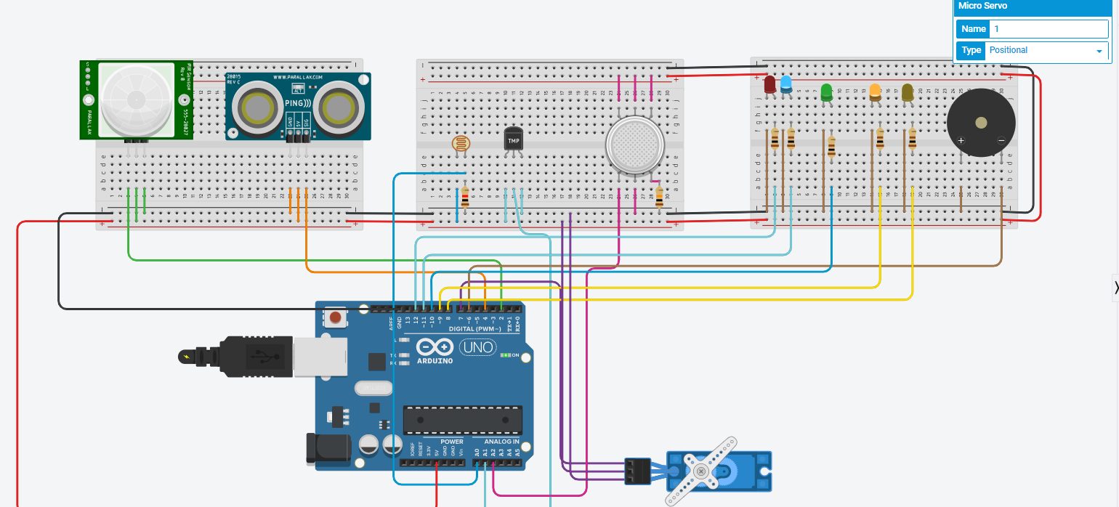
#include <Servo.h>
int inches = 0;
int cm = 0;
const int ldr = A0 ; // photoresistor
int s1,x;
int gas = A2;
int pir;
Servo servoMotor;
long readUltrasonicDistance(int pin)
{
pinMode(pin, OUTPUT);
digitalWrite(pin, LOW);
delayMicroseconds(2);
digitalWrite(pin, HIGH);
delayMicroseconds(10);
digitalWrite(pin, LOW);
pinMode(pin, INPUT);
return pulseIn(pin, HIGH);
}
void setup()
{
pinMode(12, OUTPUT);
pinMode(11, OUTPUT);
pinMode(10, OUTPUT);
pinMode(9, OUTPUT);
pinMode(8, OUTPUT);
pinMode(6, OUTPUT);
pinMode(A2,INPUT); // gas sensor
pinMode(A1, INPUT); // temperature sensor
pinMode(4, INPUT); // ultrasonic sensor
pinMode(2, INPUT); // PIR sensor
Serial.begin(9600);
servoMotor.attach(7);
}
void loop()
{
// ultrasonic sensor and servomotor
cm = 0.01723 * readUltrasonicDistance(4);
Serial.print(cm);
servoMotor.write(cm);
Serial.println("cm");
// temperature sensor
float temp = ((analogRead(A1) * (5.0/1024))-0.5)/0.01;
Serial.print( temp );
Serial.println(" C");
if(temp >= 50)
{
Serial.println("Overheated");
digitalWrite(12, HIGH);
digitalWrite(11, LOW);
}
else
{
digitalWrite(12, LOW);
digitalWrite(11, HIGH);
}
// photoresistor
s1 = analogRead(ldr);
x=(676-s1)/4;
analogWrite(10, x);
// gas sensor
gas = analogRead (A2);
if (gas > 500 )
{
digitalWrite(9, LOW);
tone(6,255,1000);
Serial.println("Smoke detected");
}
else
{
digitalWrite(9, HIGH);
digitalWrite(6, LOW);
}
// pir sensor
pir = digitalRead(2);
if ( pir == HIGH)
{
Serial.println("Object detected");
tone(6,100,1000);
digitalWrite(8, HIGH);
}
else
{
digitalWrite(8, LOW);
digitalWrite(6, LOW);
}
delay(1000);
Serial.print("\n");
Serial.print("\n");
}
Na osnovu prethodnog zadatka napraviti zadatak „pametni grad“ u kojem ćete riješiti problem paljenja i gašenja javne rasvjete, problem zagađenja, problem slobodnog mjesta na parkingu, …

